**Corporate Transport**

**Project Abstract Report**

**on**

**Corporate Transport Website**

**By**

|  |  |
| --- | --- |
| Anna Juliet | : 2472183 |
| Supra Sinha | : 2472761 |
| Tushar Sen | : 2473000 |
| Tuhin Ghosh | : 2472799 |
| Rik Banerjee | : 2473041 |
| Mahesh Gurung | : 2472902 |
| Jyoti Kumbar | : 2472410 |

Under the guidance of

**Sandip Mohapatra**

**CONTENTS**

|  |  |  |
| --- | --- | --- |
|  | **TITLE** | **PAGE NO.** |
| **1** | **Abstract** | **3** |
| **2** | **Project Overview**  -Modules | **4** |
| **3** | **Objective** | **5** |
| **4** | **Project Analysis** | **5** |
| **5** | **Project Planning** | **6** |
| **6** | **Software & Hardware Requirements**  -IDE used  -Languages used  -Server/Database used | **7** |
| **7** | **ER Diagram** | **8** |
| **8** | **Forms** | **12** |

**Abstract:**

The proposed project is a smart Corporate Transport booking system that provides users an easy way of booking a cab online. The task sometimes becomes very tedious for the customers or users in manually booking a cab by calling method. This is a web based application that overcomes the issue of manual Transport booking.One can book a cab through our website either by filling the booking form or by calling us. In this project we also have a feedback page, contact us & home page through which we can login or register.

We are designing the Front-end using angular, spring as a middleware and oracle as a backend. so whenever we fill a form on the front end, the data will be sent to the middleware and then we store the data in the form of tables in the database.

**Project Overview:-**

**Modules:** There are 5 different pages in our website

1. Home

-Pickup and drop location

- Login Page

- Registration Page

2) Booking

- Different types of car availability

* Luxury
* Economy
* Standard

- Payments

* UPI
* Credit card
* Debit card
* Cash

3) About us

- A few words about us

- Transport policy

4) Contact Us

- Our Contact address

- Email & Mobile number of our customer care

5) Feedback

- Feedback of the ride

**Objective:**

Objectives of the Project & our modern age of technology greatly depend on internet. Everything is converted to computer based for easier and faster communication. Here we are trying to develop such a system, which will ensure some aspects,

* Reliability, maintainability, cost-effectiveness and a nice user-friendly environment.
* The objective of the project is to enable easier & much quicker transport booking.
* Proper management of bookings, securely storing all records.
* Saving money and time

**Project Analysis:**

Describes the risks that can possibly arise during software developments well as explains how to assess and reduce the effect of risks. Initially the user must enter pick-up and drop location, then if the locations are available, the user will be taken to a login page where valid login details will be entered if he is an existing customer, else he can register as a new customer. After registration, he will be taken to a page to choose his ride and then to the payment page where he can choose the payment method. In the booking & Feedback pages, the details which were entered by the user should be stored in the database for further actions.

**Project Planning:**

Proper project management is essential for the successful completion of a software project. Software project management (responsible for project planning) specifies activities necessary to complete the project. After this a project schedule is prepared to accomplish the specified tasks. The purpose of planning and scheduling is to develop the software according to the user requirements within the allocated time and budget. Project planning is a part of project management, which relates to the use of schedule such as charts to plan and subsequently report progress within the project environment.

▪ Select project

▪ Identifying project’s aims & objectives.

▪ Understanding requirements & specification

▪ Methods of analysis, design & implementation

▪Testing techniques

▪ Documentation

▪ Budget allocation

▪ Project Estimation & deliverables

▪ Resources Allocation

▪ Risk Management

**Software and hardware requirements:**

1. IDE used: We are using Following IDE for building this project

* Visual Studio code: We used this IDE for running Angular in it and using node as server.
* Eclipse IDE: We used this IDE for Java Business logics.
* Spring Boot: We used this for integration of different pages and modules also it is used for Configuration of data base and frontend.

1. Languages Used:

* Java: Used for writing business logics we use it.
* HTML: Used for writing webpage or front end code.
* CSS & Bootstrap: Used for Styling of webpages/frontend.
* Javascript & JQuery: Used for form Validations and prevention from entering invalid data.
* JDBC: Used for Creating Database and entering dynamic data into the database also used for retrieving data and displaying it on webpage.
* JSP: Used for creating dynamic contents and Inserting simple Java logics into HTML pages.

1. Severs/Database used:

* Node server: Used for Routing with the help of angular.
* Tomcat server: We have used this open source server for executing java servlets and JSP.
* Oracle database: We used oracle database for storing our data.

**ER Diagram:**

**Forms:**

Pick up/Drop:

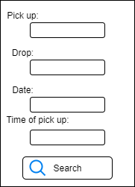

Registration:

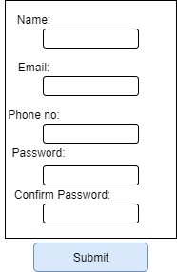

Login:

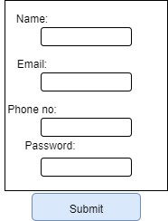

Booking:

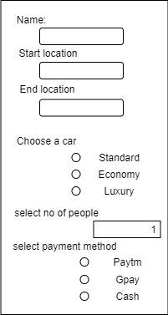

Contact Us:

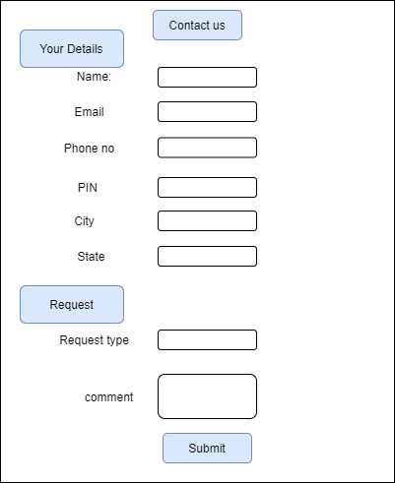

Feedback:

